Getting Started With VideoImpression 2.0
VideoImpression is a powerful, easy-to-use video editing and presentation program. It enables you to edit video clips and still images, and to combine them to create multimedia desktop video presentations.

I. Getting Started.
1. Click Start.
2. Select Programs>ArcSoft VideoImpression 2>VideoImpression 2. The VideoImpression main screen will appear as below.
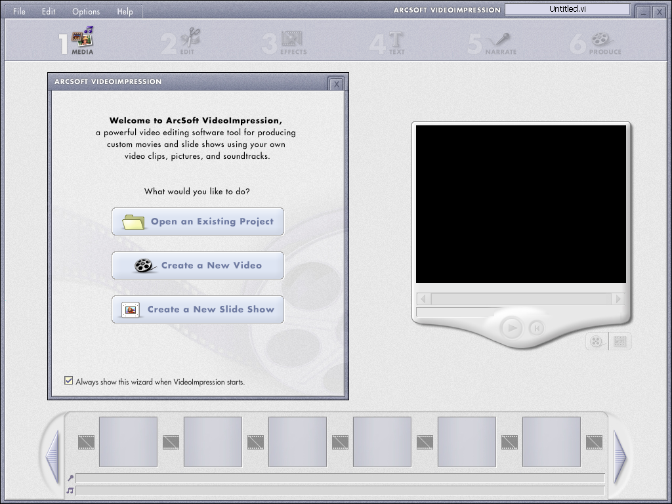

II. Create New Video With your Webcam.
1. Click 'Create a New Video' icon.


2. Click 'Capture From Device' icon.


3. Choose the name of your webcam.

4. Click record button to capture video.


Refer to the user's guide of VideoImpression in the CD-ROM comes with your webcam to learn more about how to use the other powerful functions of VideoImpression.

Getting Started With PhotoImpression 4.0
PhotoImpression is an easy-to-use image-editing program specifically designed for general consumers. The program enables you to edit, retouch, enhance or add special effects to digital images with point-n-click simplicity.
I. Getting Started.
1. Click Start.
2. Select Programs>ArcSoft PhotoImpression 4>PhotoImpression4. The PhotoImpression Main Screen will appear as below.
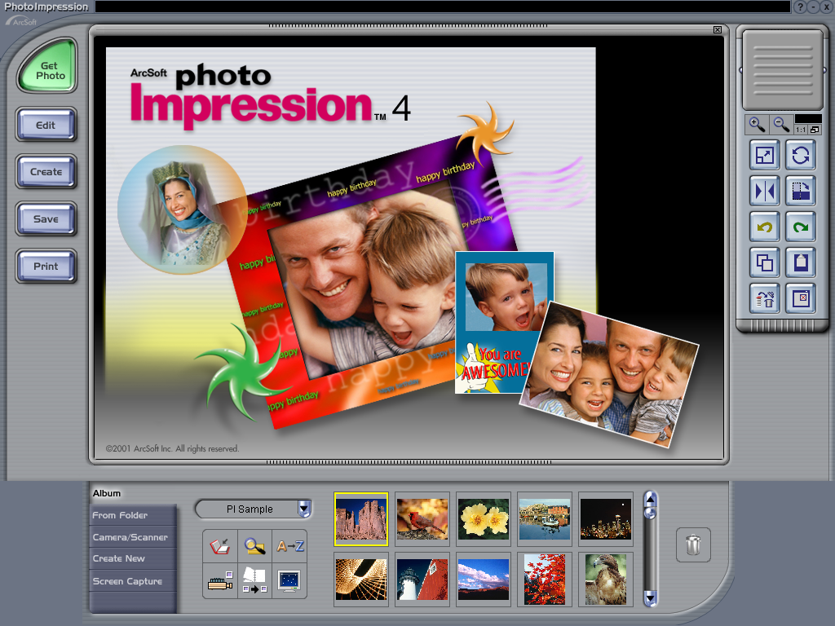

II. Capture New Photo With Your Webcam.
Your webcam is recognized by PhotoImpression as a digital camera as well as a video camera. So, you may get the image from your webcam by either way.

1. Capture new photo from your webcam as a digital camera.

1.1 Click the 'camera/scanner' button and the following screen will appear.
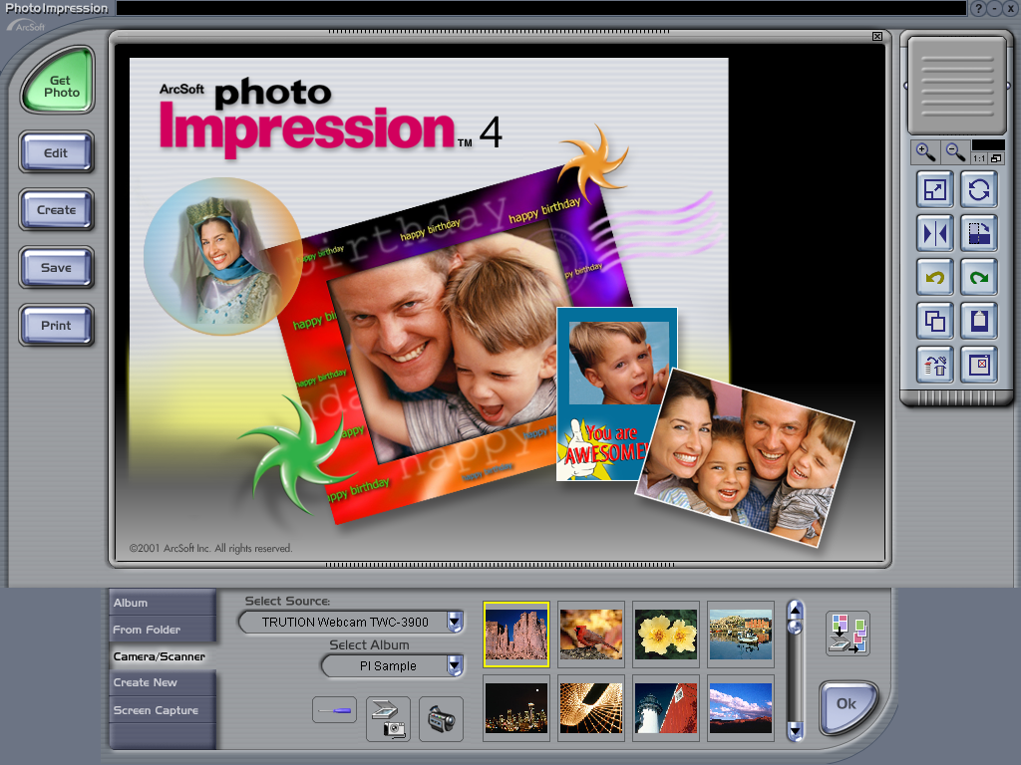

1.2. Click on the 'scanner & camera' icon and the following screen will appear.
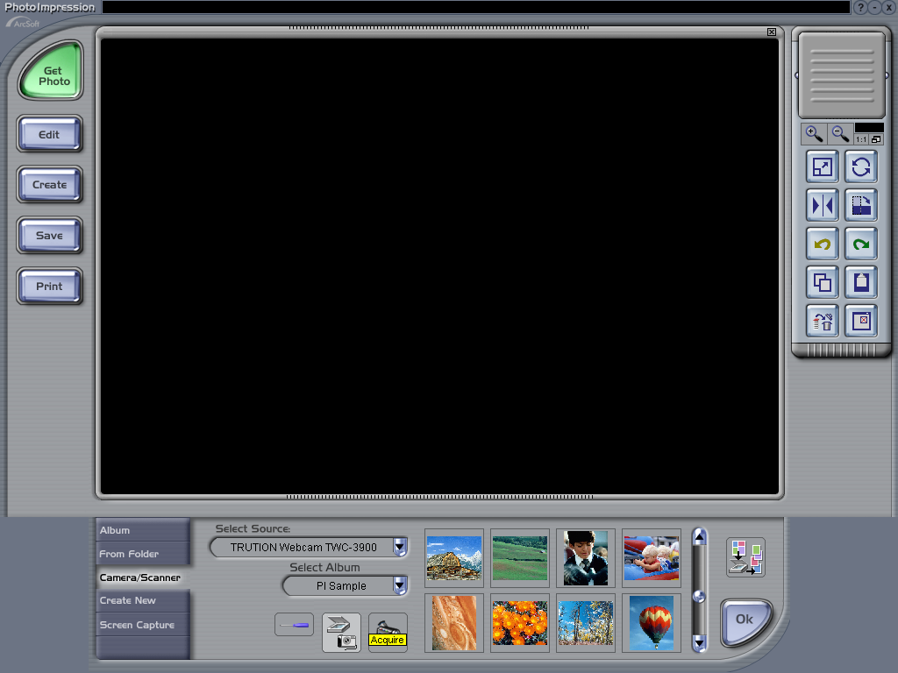

1.3. After clicking 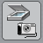 icon, the following screen will appear. Click 'Capture' button to capture the image.
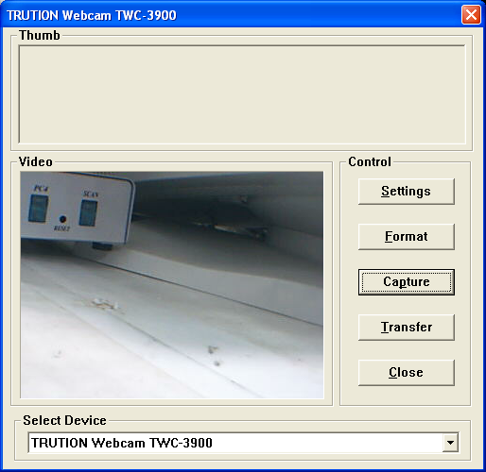

2. Capture new photo from your webcam as a Video Camera.
2.1 From the main screen, click 'Camera/Scanner' and 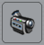 button, the following screen will appear.
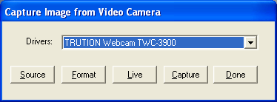

2.2 Choose the name of your webcam and click 'Live' button, the image from your webcam will appear.

2.3 Click 'Capture' to capture the image.

